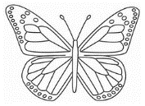
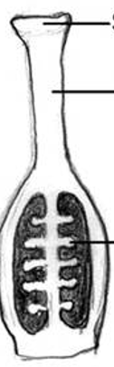
General Characteristics:
+ Eukaryotes
+Autotrophs
+Cell wall
+Immobile
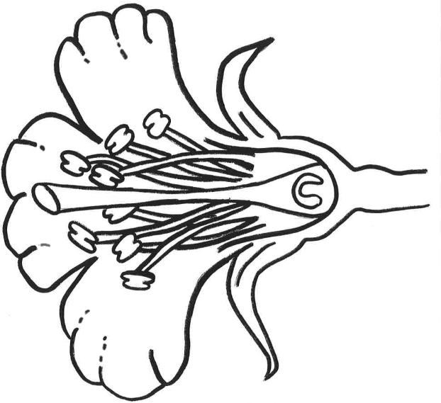
+Vacuole

Angiosperm:
Flower: Perfect:

Imperfect:

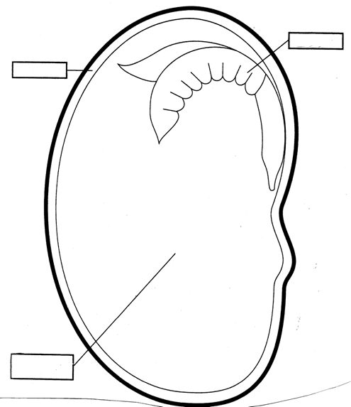
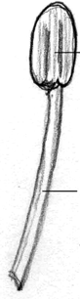

Seed dispersal:
1 3
2 4
Vascular tissue:
Function – _________________
- Composed of xylem and phloem
Xylem:

Phloem:

STEM
Function:
Above ground
Main axis of plant
Allows plants to overcome gravity
Connection between _________ and ____________

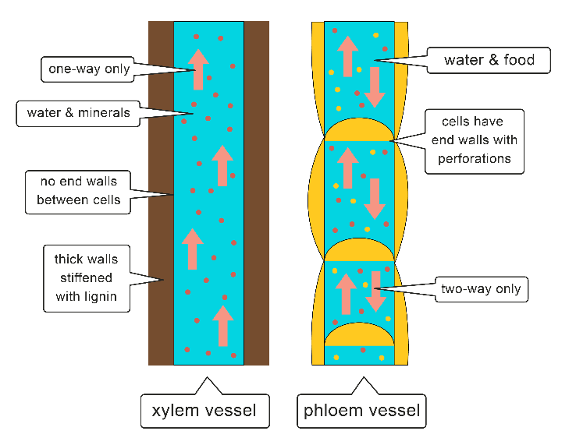
Preventing water loss
+Cuticle:_____________________
+Lipids do not dissolve in _______
+
All vascular plants have tissues
- types
  - Dermal tissue:

  - Ground tissue:

  - Vascular tissue:

2

3 4

1

