Electric Circuit Project

Objective: I will demonstrate understanding of simple circuits by designing a game to help students quiz for knowledge and know whether they are right or not. And, at the same time, learn about designing, constructing, and testing a circuit.

Circuit Game:

Arrange the questions and answer choices on a piece of cardstock in a creative, colorful, eye-catching way.

1. Using simple materials such as batteries, aluminum foil, tape, and small light bulbs or buzzers, create a simple circuit for each question connecting it to the correct answer choice so that when a question is answered correctly, a light or buzzer goes off. An incorrect answer should result in nothing happening. A piece of thick paper should be attached to cover the “guts” of the project.
2. Using the following vocabulary, explain why the light or buzzer works with the correct answer but not with the incorrect ones:

* Potential Difference
* Current
* Resistance / Resistor
* Closed Circuit
* Open Circuit
* Conductor
* Insulator
* Series Circuit
* Parallel Circuit

1. The overall project will be a PROJECT GRADE on this 9 weeks.

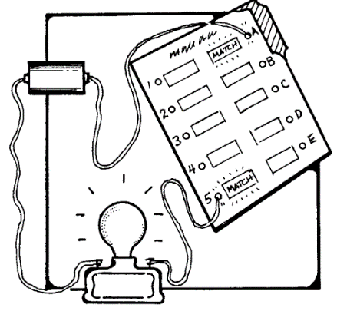

Your finished project should look similar to this illustration.

|  |  |
| --- | --- |
| **Grading**: |  |
| All 5 circuits work as they should: | 55 points |
| Only 4 circuits work as they should: | 45 points |
| Only 3 circuits work as they should: | 35 points |
| Only 2 circuits work as they should | 25 points |
| Only 1 circuit works as it should: | 15 points |
| Creative artwork (hand drawn)/color on folder: | 15 points |
| Explanation (using vocabulary) of why the game signals the correct answer, but not an incorrect answer ** | 30 points |
| Include one extra parallel circuit | Bonus 5 pts |
|  |  |
| Total points possible: | 100 points |

**\*\* DO NOT PLAGERIZE/CHEAT/STEAL/BORROW/USE SOMEONE ELSE’S WORK AS YOUR OWN!!!!!**

**There are an infinite number of ways to structure sentences as well as ways to order the 7 vocabulary terms. If your paragraph looks related to any other paragraph, no credit will be given for your explanation.  That means the highest you can score will be a 0. DO NOT DO IT! YOU WILL BE CAUGHT AND PROSECUTED! \*\***

Electricity Project – Planning Page:

Game Theme: _______________________________________

Questions & Answers: make sure all answers could be a potential match (don’t make one a number, one a color, one an animal, etc.)



Plan your arrangement of questions and answers here (what the inside circuit will look like):