Name:_____________________________________ Period:_______

2016-2017 Semester 1 TEST Study Guide A

Photosynthesis Process and Cellular Respiration Process:

- Write the balanced chemical equation for Photosynthesis

- Write the balanced chemical equation for Cellular Respiration

- Photosynthesis occurs in the ________________________

- Cellular Respiration occurs in the ______________________

- The purpose of Photosynthesis is to make ______________________

- The purpose of Cellular Respiration is to convert _____________ into _________ energy

- ___________________________uses carbon dioxide

- ___________________________ produces carbon dioxide.

Cycle of Energy Notes:

1.Write the reaction for photosynthesis:
______________ + _______________ + _______________ - _______________ + _________

2. Define photosynthesis: ____________________________________________________________________
______________________________________________________________________________

3. Photosynthesis happens in the _________________________________________ of _______________cells.

4. Write the reaction for cellular respiration:
____________ + _______________ - _______________ + _______________ + ___________

5. Define cellular respiration: _________________________________________________________________
______________________________________________________________________________

6. Respiration happens in the ______________________________of_________________cells.
7. Photosynthesis and respiration are mostly ____________________________________ of each other.
8. What is the whole purpose of the cycle of photosynthesis and respiration?
______________________________________________________________________________

Cellular Energy
- Draw and label a ATP molecule

- How does a cell get its energy from an ATP molecule
- Draw and label a ADP molecule

Cell Structure and Organelle Functions

- List 3 organelles that are in plant cells but not animal cells.
- Write one organelle that is in an animal cell and not a plant cell.
- What is the function of a Lysosome?
- ____________________ is found in plant cells and its function is to give the cell a rigid structure.
- Label the following Plant Cell
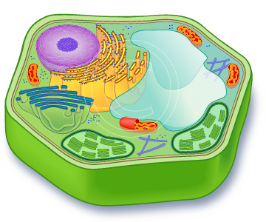

- Label the following animal cell:
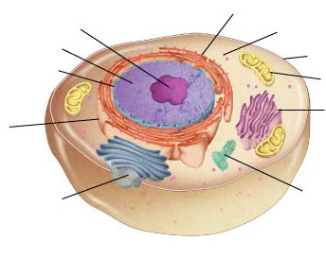

- Label the cells below either Prokaryote or Eukaryote
_________________________ _________________________

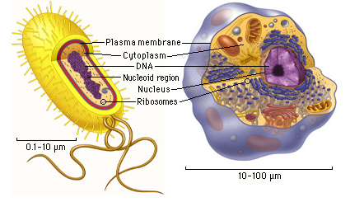

- What are the differences between a prokaryote and eukaryote?

Cell Theory
1. State the three parts of the cell theory:
a. ______________________________________________________________________________
b. ______________________________________________________________________________
c. ______________________________________________________________________________
2. What technology was necessary before the Cell Theory could be discovered?
___________________________________

Cell Organelles

1. Write the function of each of the following:
a. cell wall: _____________________________________________________________________________
b. cell membrane: ________________________________________________________________________
______________________________________________________________________________
c. cytoplasm: ____________________________________________________________________________
d. nucleus: ______________________________________________________________________________
e. nuclear membrane: _____________________________________________________________________
f. chromatin: __________________________________________________________________________
g. endoplasmic reticulum (E.R.): ____________________________________________________________
h. ribosome: _____________________________________________________________________________
______________________________________________________________________________
I. mitochondria: __________________________________________________________________________
______________________________________________________________________________
j. chloroplast: ____________________________________________________________________________
______________________________________________________________________________
k. lysosome: ____________________________________________________________________________
______________________________________________________________________________
l. vacuole: ______________________________________________________________________________
______________________________________________________________________________
m. golgi body: ___________________________________________________________________________
n. centriole: _____________________________________________________________________________

Name:_____________________________________ Period:_______
2016-2017 Semester 1 TEST Study Guide B
Cell Transport
- Active transport moves molecules from an area of ____________concentration to _________concentration.
- Passive transport moves molecules form and area of __________ concentration to __________ concentration.
- ______________ transport requires energy and ________________transport does not.

The drawing shows four beakers with 100mL of different concentrations of sucrose solutions. Identical slices of kiwi with a sucrose concentration of 37% were placed in each beaker. Use the diagram below to answer questions 4-8.
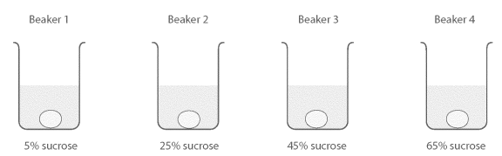
4. Label the sucrose and water concentrations for the inside of the cell on the diagram.
5. Label the water concentration found in each beaker under the sucrose concentration.
6. Draw an arrow showing which way water will diffuse.
Beaker 5 - Control
Label each beaker as hypo, hyper, or isotonic solution.
7. Which solution will LOSE the MOST mass after 4 hours.
9. Draw a 5th beaker in the box to the right that shows a control
set up for this experiment.

10. What is the difference between active and passive transport?
11. Explain both reasons cells have to use active transport:
1.)____________________________________________________________________________
2.)____________________________________________________________________________

12. What do we mean when we say a cell membrane is semi-permeable?
13. Label the parts of the cell membrane
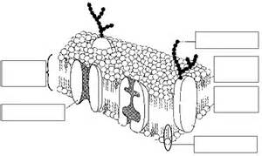
Bacteria and Viruses
- What is the difference between bacteria and viruses?

- What do both bacteria and viruses have in common?

- How are bacterial infections treated?

- How are viral infections treated?
- How would you prevent a flu virus?

- How would you cure a cold virus?
- How would you cure a strep throat bacterial infection?

Plants
- Label the reproductive structures in a flower.
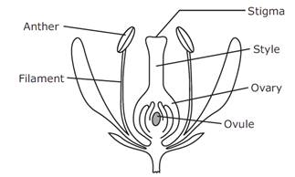
- What is thigmotropism?
- What is geotropism?
- What structures in a plant allow for the transport of water and nutrients throughout a plant?
Taxonomy
- Match the following to their respective characteristics.
Animalia Mobile, eukaryote, heterotroph
Plantae Immobile, autotroph, eukaryote
Fungi Immobile, heterotroph, eukaryote
- Place the following levels of taxa from most closely related to least related.

  - Domain
  - Phylum
  - Kingdom
  - Order
  - Genus
  - Family
  - Class
  - Species

______, ______, _______, ________, ________, ________, ________, _________
- What are the two parts of a scientific name?
- How is a scientific name written?

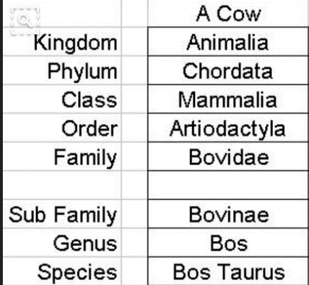
- Given the information in the chart below what is the scientific name of the Cow?

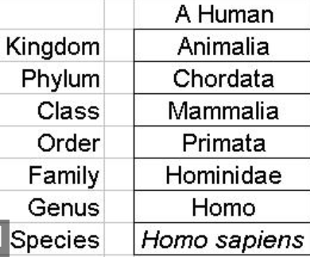
- Given the information in the chart below what is the scientific name of the Human?

Macromolecules and Enzymes
- How can you identify an enzyme in a test question?
- What is an enzyme?
- How do enzymes affect a chemical reaction?
- What three factors can affect how well an enzyme works?
- Which element is most abundant in all organic compounds (macromolecules)?

- Fill in the following table with the Macromolecule (organic compound) information
Macromolecule (Organic Compound) | Monomer | Polymer | Elements | Functions/key words

Scientific Method and Graphing
- What measuring tools would you use to measure the volume of a liquid in lab?
- Of the three tools shown which one would be the most precise measurement?
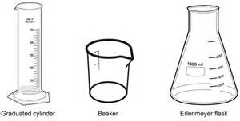
- What measuring tools would you need to measure the mass of an object?
- A team of students wanted to determine if slugs preferred green foods to non-green foods. They set up an experiment using one slug per container. The results are shown in the data table below. 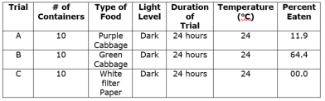
What should be concluded from this data?

Growth Chart
Age (year) | Average Height (cm)
5 | 109
6 | 115
7 | 120
8 | 125
9 | 130
10 | 145
11 | 152
12 | 160
- Katia conducted an experiment to look at the relationship between age and average height. A summary of her results are shown in the data table above. Prepare a graph of the data from Katia’s experiment.

- List the steps of the scientific method.

Body Systems
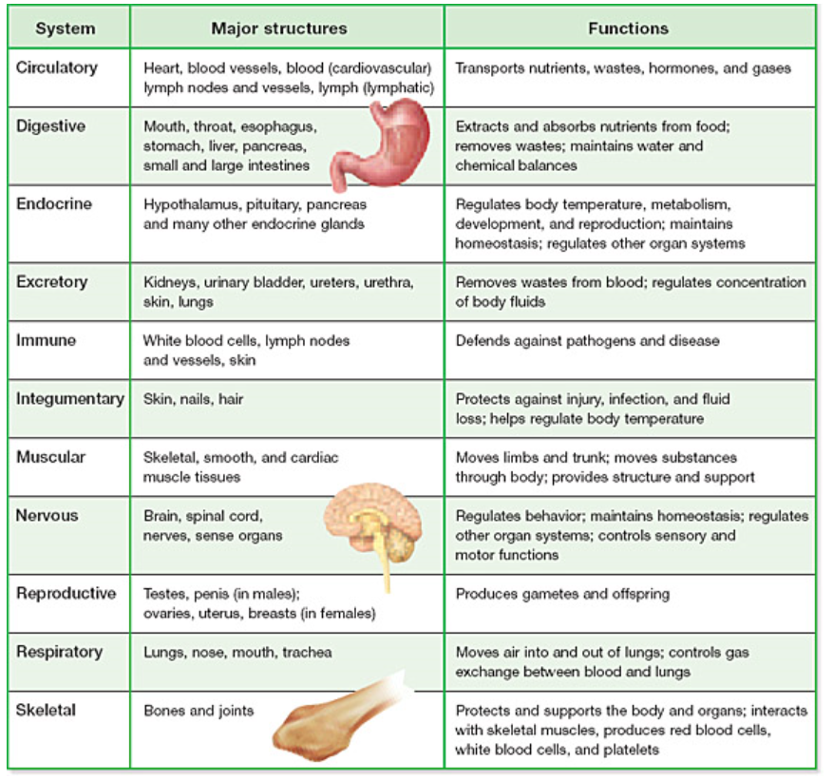
Fill in the following chart with the appropriate information:

Name:_____________________________________ Period:_______
2016-2017 Semester 1 TEST Study Guide C

- What is a control group?

Use the chart below to answer 2 - 5.
- What are the 4 types of biomolecules?
- What elements make up each biomolecule?
- What are the Monomers/polymers of each?
- What are their functions?
Name of Biomolecule | Elements that make up that biomolecule | Monomers/Polymers | Function/ FOOD
- Draw a quick sketch of the chemical makeup of a carbohydrate, a lipid, and an amino acid. Diagram and label the key parts of a nucleotide.
Carbohydrate: Lipid:

Amino Acid: Nucleotide:

- What is the role of enzymes in the body?
- Think of what the graph of an exothermic reaction looks like. Now consider the same reaction, but with an added enzyme. What will look different on the graph? Draw a graph with explanation.

- What do enzymes do in a chemical reaction?

- List the organelle that goes with each of the following functions.
ORGANELLE | FUNCTION
 | Super highway to move things from one part of cell to another. No ribosomes
 | Control center of the cell. The nucleolus is found here.
 | Gatekeeper of the cell. Allows some things in and keeps other things out.
 | Manufactures protein synthesis. Some are found on the ER others are floating free
 | Transport of proteins & lipids throughout cell. Has Ribosomes
 | Converts light to energy. Only in plant cells.
 | Converts energy to forms the cells can use. (ATP) Powerhouse of the cell.
 | Packages and delivers proteins and lipids. The UPS of the cell.
 | Digests and gets rid of used parts of cell with enzymes
 | Stores water and waste until eliminated
 | Gel – like substance that allows organelles to move around freely.
 | Gives protection and support for the plant. Made of cellulose.
- Why are lysosomes necessary in eukaryotic cells?

- What is the difference between and autotroph and a heterotroph?

- What is the primary function of the cell membrane? What physical characteristic allows for this function to take place?

- What is the role of proteins in the cell membrane?

- Fill in the boxes below:
Organelle or substance | Found in Prokaryote, Eukaryote, or Both (P,E, or B)
Nucleus
Mitochondria
Chloroplast
ER
Ribosome
Genetic material

- Where is DNA stored in a eukaryotic cell?

- Label each of the following as one of the following: virus, eukaryote, or prokaryote

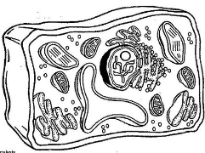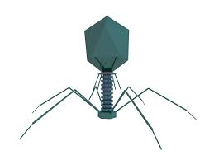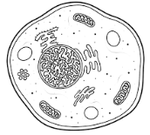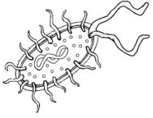

- Fill in the following chart with the following terms, as needed:
(Cell type) Prokaryote, Eukaryote,
(# of cells) Unicellular, Multicellular,
(Feeding type) Autotroph, Heterotroph

Kingdom | Cell Type | # of Cells | Feeding Type
Protista |  | Mostly _____cellular
Fungi
Plantae
Animalia

- Describe the methods used to treat for, or prevent, a bacterial infection and a virus.

Bacteria:

Virus:

- What is Binomial Nomenclature?

- What is DKPCOFGS as it relates to taxonomy?

- Which of the following are most closely related? Why did you chose the answer you chose?
Scientific Name | Common Name
Lutjanus campechanus | Red snapper
Penaeus aztecus | Brown shrimp
Panulirus argus | Spiny lobster
Ocyurus chrysurus | Yellowtail snapper
Penaeus duorarum | Pink shrimp
Siconia brevirostris | Rock shrimp

- What is diffusion and how is it different from osmosis?

Carefully consider the following questions. What type of solution is the cell and what type of solution is the surrounding solution in the beaker? (no answer here, just thought)
- Imagine a cell that is hypotonic to its surroundings. The cell is permeable to water but not the solute (like salt). Is the cell swelling, shrinking, or staying the same size? Explain the justification of your answer.

- Same scenario only the cell is hypertonic to the surrounding environment. Is it swelling, shrinking, or staying the same? Explain the justification of your answer.

- What does isotonic mean?

- When measuring liquids, you are measuring volume. Name two pieces of lab equipment used to measure liquids.

- Of the above 2 pieces of equipment which would give you the most precise measurement?

- When measuring mass, what type of equipment would you use?

- List the steps of the scientific method.
  - __________________________________________
  - __________________________________________
  - __________________________________________
  - __________________________________________
  - __________________________________________
  - __________________________________________
- During which step of the scientific method should safety precautions be planned?
__________________________________________

- Draw a diagram of a cell membrane – include and label the phospholipids, membrane bound proteins, the intra/extracellular sides.

- What is the function of a protein channel?

- What is photosynthesis and why is it so important to all life on Earth? Where does the reaction take place, what are the reactants/products?

- What is cellular respiration and why is this so important to life on Earth? What are the 2 energy pathways that respiration can follow-What’s the same and what’s different? List the steps of each pathway and where do they occur, and the reactants and the products of those different types of respiration?

- How do photosynthesis and cellular respiration relate to each other? How are they similar?

*Be able to read graphs, and data charts. Be able to recognize a virus and bacteria diagram and know the differences between plant and animal cells. PLEASE go to Stupkascience.weebly.com to view the practice test and review keys.

